Video Clips.

Q3 2016.

Formavision's newsletter for trainers & training resource managers
Contents:
New DVDs and video on demand with on line previews
Special Prices for Education Nationale, Universities, Afpas, Cfas
Small Companies 1 to 10 employees and Language schools

For new DVDs and videos visit http://www.formavision.com/newvo.html
On line DVD VOD Catalogues in English On line DVD VOD Catalogues in French

Managing Me

"It's not what happens to you, but how you react that matters."
View a sample using Windows Media Player!
As the leader of any group, problems are inevitable. So...how do you react?
Do you lead with your gut...or your head?
When problems arise at work, he can choose to react with either impulse or reason.
As each situation plays out, the better reaction is clear. Viewers recognize that how you react often has a far greater impact on morale, on retention, on productivity--than any specific problem ever could.
The key to managing other people is learning how to manage you.
Running Time: 19 Minutes
This program includes:

A comprehensive 28 page leader's guide with reproducible participant worksheets

A 20 page PowerPoint Slide Presentation The slides may be edited for your organization's needs.
Both leader's guide and participant worksheets are formatted as PDF files and may be reproduced as needed.

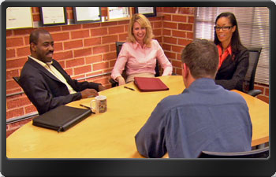

Customer Service Gone Viral

It used to be when someone received bad service, they would tell a few friends...now, they tell the world."

You can't help but notice that almost everything we do now has a chance of being recorded, reviewed and presented to the entire planet. Without question, customers are making their buying decisions based on what they see online. This new kind of customer feedback puts service providers in a very vulnerable position, but there is something you can do about it.

View a sample using Windows Media Player!

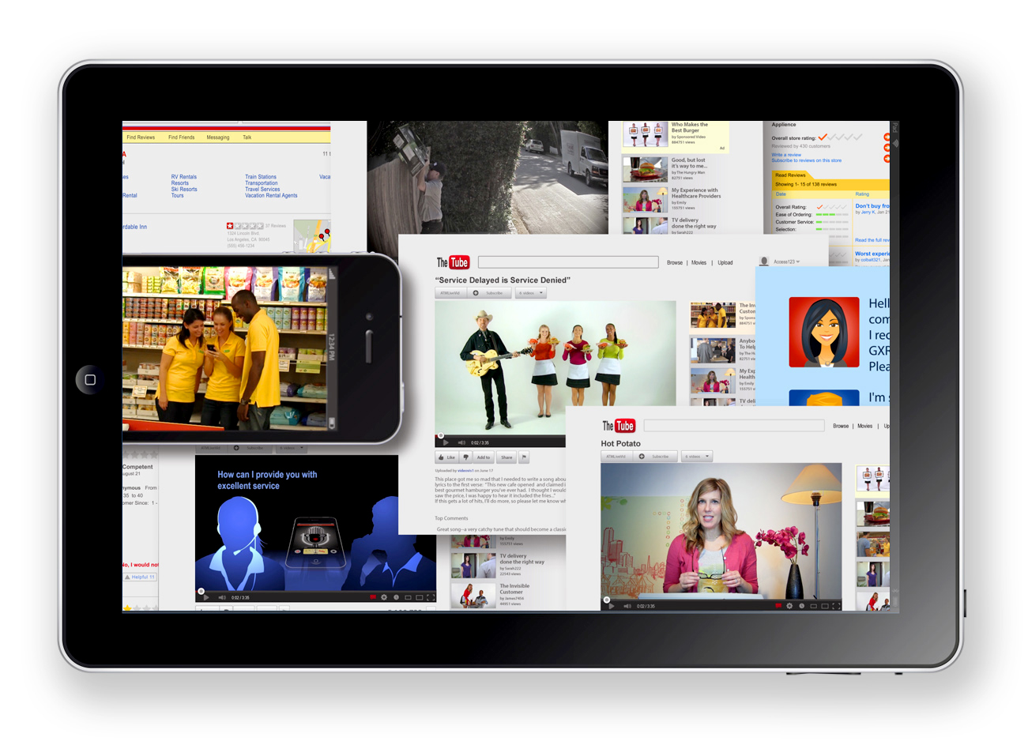

Talk Isn't Cheap!
Poor communication costs money. Using the skills demonstrated in this video, viewers will communicate more clearly and reduce unnecessary costs in time, morale and money...
View a sample using Windows Media Player!
The video also dramatically illustrates the significant expense of careless communication errors. The cumulative cost of these, sometimes small, sometimes devastating, errors can chisel away at a company's profitability.

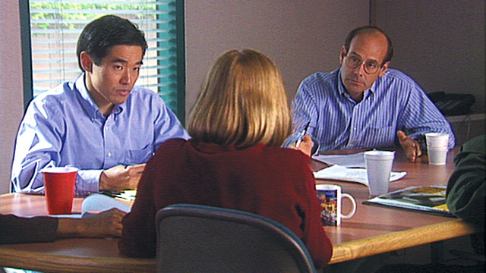

Would I Inspire Me?
When workers know their work makes a difference, productivity rises and so does job satisfaction.
Psychology Today, "Making a Difference at Work"

The Would I Inspire Me? video program gives viewers practical ways to make work life more meaningful, productive, and rewarding for themselves and their team.



The Mind of a Leader based on Niccolò Machiavelli's 'The Prince'


'The Mind of a Leader' is an international cutting-edge leadership project led by Benjamin Holk Henriksen and Fredrik Lassenius. Interviews with 34 international top leaders and experts from different cultures and trades all over the world on how they deal with the very sensitive and controversial issues raised in Niccolò Machiavelli's timeless masterpiece: 'The Prince' (Italy, 1513) and Sun Tzu's 'The Art of War' (China 500 B.C.).
The result is the 26 chapter documentary series 'The Mind of a Leader I'

The Mind of a Leader II based on Sun Tzu's 'The Art of War'


24 famous international top leaders and experts within business, politics, art, sports, organized crime, philanthropy and health care are united in a timeless and universal documentary about leadership, ethics and visions. The topics discussed are closely related to the issues raised in the 13 chapters of Sun Tzu's masterpiece: "The Art of War" (China, 500 B.C.) one of the oldest preserved strategic dissertations on the science of warfare.
"The Mind of a Leader II" is an outstanding training & development tool.



The Mind of a Leader Animation Series
The Mind of a Leader Animation Series gives you an illustrated and easily accessible introduction to each chapter of the controversial Renaissance masterpiece The Mind of a Leader based on Niccolò Machiavelli's 'The Prince' and the strategic cornerstone work The Mind of a Leader II based on Sun Tzu's 'The Art of War'

The series incorporates modern symbols to enhance the understanding of the original text and state its relevance from a modern perspective.
Fish is yet again our bestselling title in 2014

Details http://www.formavision.com/osvo4.html

Special Prices for Education Nationale, Universities, Afpas, Small Companies 1 to 10 employees (Club Formavision) and Language schools

Call Formavision at 06 75 03 55 47 for more information or email dvd@formavision.com

To view the new DVDs and videos visit http://www.formavision.com/newvo.html
Call Formavision at 06 75 03 55 47 for more information or email dvd@formavision.com
Secure On line ordering

You can order our products using our secure server for credit card orders. http://www.formavision.com/secure.html

Bruce Duncan-Smith -- Marketing Director. Formavision, France.
Tel 06 75 03 55 47 http://www.formavision.com

To unsubscribe
If you do not want to receive this eNewsletter, please reply to this email with "unsubscribe Video Clips newsletter" in the subject line and be sure to indicate the email address you want removed, especially if your mail is consolidated at a mailbox other than the one to which we've addressed Video Clips

